**Department of**

**Computer Science and** **Engineering**

# Social Activity Report

**On**

# SPREADING AWARENESS TO AVOID LITTERING

***Submitted in partial fulfillment of the Requirements for the award of***

***Bachelor of Engineering degree*** **in** **Computer Science & Engineering**

By

**Gaurav V**

***USN:* 1MS18CS046**

Under the Guidance of

**Dr. Geetha J**

**Associate Professor in Computer science**

# S Ramaiah Institute of Technology, Bangalore

## Department of Computer Science & Engineering

**Bangalore - 560054, Karnataka, India**

**Jan 2020 - May 2020**

 **Department of** **Computer Science and Engineering**

# CERTIFICATE

*This is to certify that the Social Activity entitled “spreading awareness to avoid Littering” is a bonafide record of the Social Activity for 100 point activity carried out by* ***Gaurav V (USN: 1MS18CS046)*** *under my guidance, in partial fulfillment of the requirements for the Bachelor of Engineering, Computer Science & Engineering from M S Ramaiah Institute of Technology, Bangalore for the academic year 2019-2020.*

Dr. Geetha J

*Associate Professor*

*Dept. of Computer Science & Engineering*

Dr. Anita Kanavalli

*Professor & Head*

*Dept. of Computer Science & Engineering*

## Place: Bangalore Date: 5th December,2020

## ACKNOWLEDGEMENT

I would like to extend my gratitude to the HOD of the Computer Science Department and our proctor for inspiring us to take up this activity and guided us and helped us in every way possible and provided us an opportunity to understand how littering is affecting our environment and society and providing us means to spread this awareness to others.

***Gaurav V***

## ABSTRACT

Litter consists of waste products that have been discarded incorrectly, without consent, at an unsuitable location. Litter means to drop and leave objects, often man-made, such as aluminium cans, paper cups, food wrappers, carboard boxes or plastic bottles on the ground, and leave them there indefinitely or for other people to dispose of as opposed to disposing of them correctly. Large and hazardous items of rubbish such as tires, electrical appliances, electronics, batteries and large industrial containers are sometimes dumped in isolated locations, such as national forests and other public lands. It is a human impact on the environment and remains a serious environmental problem in many countries. Litter can exist in the environment for long periods of time before decomposition and be transported over large distances into the world's oceans. Litter can affect the quality of life.

The I LOVE TO CARE(INDIA) organisation has given us an opportunity to spread awareness people about how littering is harming the environment and how we can use sign boards to educate them to dispose waste properly.

## CONTENTS

**Chapter No** **TITLE** **Page no.**

|  |  |  |
| --- | --- | --- |
| **1.** | **Introduction** | **6** |
| **2.** | **Sign-Board Applications** | **7** |
| **3.** | **About the NGO** | **8** |
| **4.** | **Details of the activity** | **9** |
| **5.** | **Outcome** | **10** |
| **6.** | **Conclusion** | **11** |
| **7.** | **Reference** | **12** |

## CHAPTER 1

### INTRODUCTION

Litter can remain visible for extended periods of time before it eventually biodegrades, with some items made of condensed glass, Styrofoam or plastic possibly remaining in the environment for over a million years. About 18 percent of litter, usually traveling through stormwater systems, ends up in local streams, rivers, and waterways. Uncollected litter can accrete and flow into streams, local bays and estuaries. Litter in the ocean either washes up on beaches or collects in ocean gyres such as the Great Pacific Garbage Patch. About 80 percent of marine debris comes from land-based sources. Some litter that is collected can be recycled, however degraded litter cannot be recycled and eventually degrades to sludge, often toxic. The majority of litter that is collected goes to landfills.

A signboard is a piece of wood or paper which has been painted with pictures or words and which gives some information about a particular place, product, or event. The signs should be placed in high littered areas and those that are prone to littering, such as the streets near public transport stations. Routes used on a daily basis by pedestrians and commuters also deserve “stop littering signs” to constantly remind people that littering is a bad thing and should thus be avoided. According to a study, When an anti-littering sign appeared on an alley wall, the proportion of people who littered there declined from 47% to 39%.

## CHAPTER 2

### SIGN BOARD APPLICATIONS

1. As stated above when sign boards are used in alley ways and parks, it enables people to dispose waste properly in waste bins rather than just casually disposing them otherwise they might end up being judged by other people.

1. On disposing waste properly into waste bins, it reduces the burden on sanitary workers and enables to work more efficiently and help better maintain our parks, alleys, etc.

1. A research study was conducted using sign boards in a university cafeteria. This resulted in a significant decrease in the litter. This also showed that using positively worded messages in sign boards helped in further reducing littering in the campus.

1. Using sign boards to convey the message about recycling has further reduced littering. Recycling will help reduce waste sent to landfills, prevent pollution, saves energy, increase economic security, etc.

1. Using sign boards will reducing littering and encourage people to clean their environment and help further improve the aesthetics of the land.

.

## CHAPTER 3

### ABOUT I LOVE TO CARE(INDIA)

I LOVE TO CARE(INDIA) is a charitable trust. This organization helps to improve the community and the environment by conducting many projects with NGOs. This organization is committed to the global struggle for the society and responding quickly to challenges and opportunities for the future.

The trust supports innovative projects and is working to solve some of the most pressing problems as per all 17 United Nations Sustainable development goals.

## CHAPTER 4

### DETAILS OF IMPLEMENTION OF THE ACTIVITY

The activity was conducted in our 5th semester on 5th December,2020. Due to the ongoing Covid19 pandemic the representatives had meets on zoom and told us the various activities we can undertake to help the community. Some of the activities included making sign boards, reading stories to orphanages, etc.

The activity chosen by me was “Making sign boards to spread awareness to not litter”. The reason I chose this is because there are lot of people in my area who throw waste carelessly without thinking about the consequences caused to the environment. After going online and looking through many samples of sign boards online, I chose the one which depicts a person throwing waste into a waste bin. After choosing the appropriate image, I went and got the necessary materials I went on to make the sign board which took about two and half to three hours.

After making the sign board I took it and put it up on my door so that any passer-by and neighbors can see the sign and throw the waste into the necessary waste bins. After a few days I took the board outside to neighboring areas, to spread the message to many people in order to help reduce littering and further help to improve the environment. With the help of a few friends, we made few more sign boards and went to more areas in order to spread the message to many more people.

## CHAPTER 5

### OUTCOME ANALYSIS OF SOCIAL ACTIVITY

We had carried out the activity on 5th December,2020. This activity helped me realize the importance of looking after the environment and the importance of properly disposing waste items. This also helped me spread the message to many people and hopefully they will understand the importance to not litter. Below are some of the images of the activity:

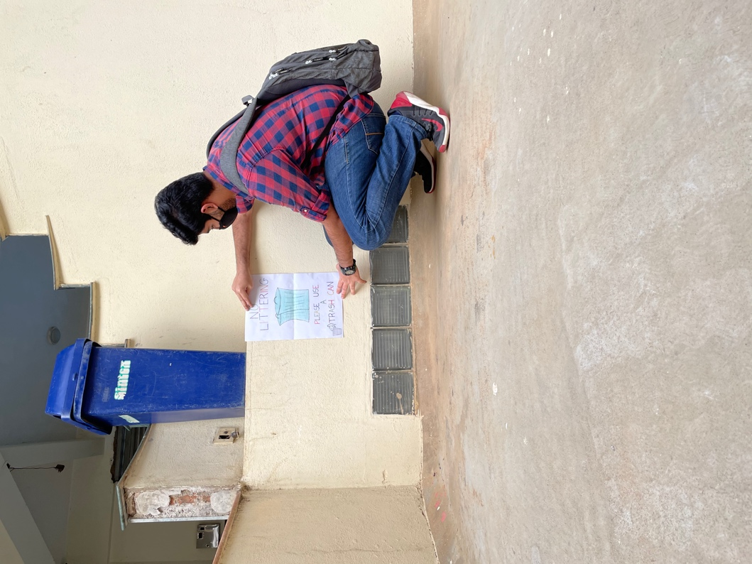

**Putting the sign board up**

**Spreading Awareness**

## CHAPTER 6

### CONCLUSION

The activity held by the I LOVE TO CARE(INDIA) trust helped me realize the importance to not litter. This activity helped me spread the message to not litter to many people and help them understand the importance of keeping the environment clean and healthy. Carrying out this activity will help keep the parks and other areas clean and will hopefully reduce the workload of sanitation workers.

### REFERENCES

 **https://in.pinterest.com/hemak5/do-not-litter-signs/**

 [**https://en.wikipedia.org/wiki/Litter**](https://en.wikipedia.org/wiki/Litter)

 [**https://www.texasdisposal.com/blog/the-real-cost-of-littering/**](https://www.texasdisposal.com/blog/the-real-cost-of-littering/)

 **https://in.linkedin.com/in/i-love-to-care-india-charitable-trust**